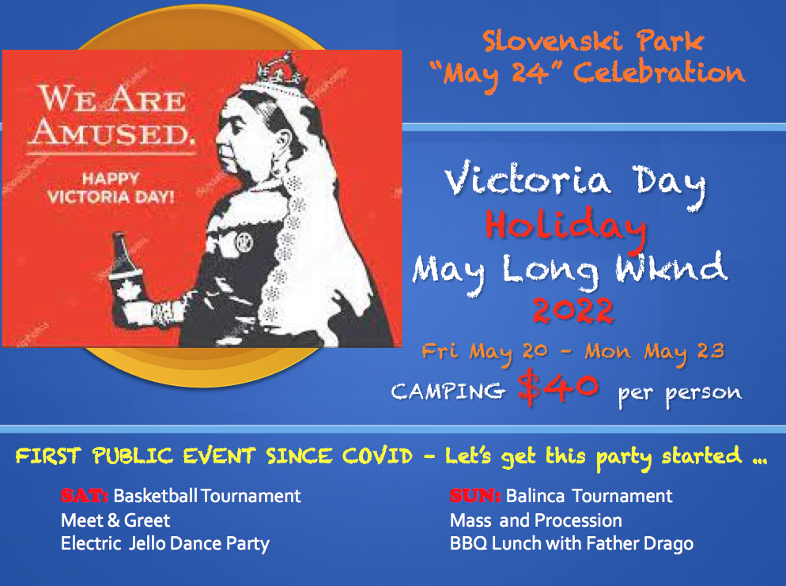
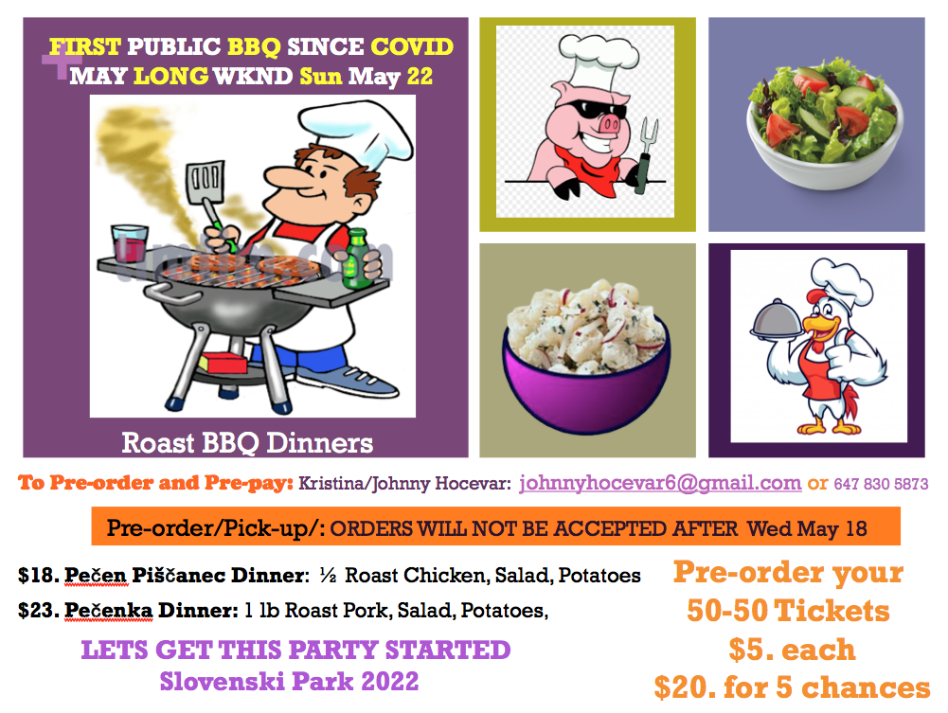

Victoria Day - "May 24" - Long Weekend Itinerary

SEE YOU THERE!!! INVITE YOUR FRIENDS!!!
$20 per day if NOT Camping

Saturday:
Basketball Tournament (please pre-register)

Meet & Greet (get to know the Board and Executive)

Electric Jello Dance Party with DJ Joe (wear white)
Sunday: ​
Mass & Procession (readers welcome)

Lunch & BBQ with Father Drago (please pre-order any food)

Balinca/Bocce Tournament (please pre-register)

